**Destiny Clock**

**DESIGN CONVENTIONS**

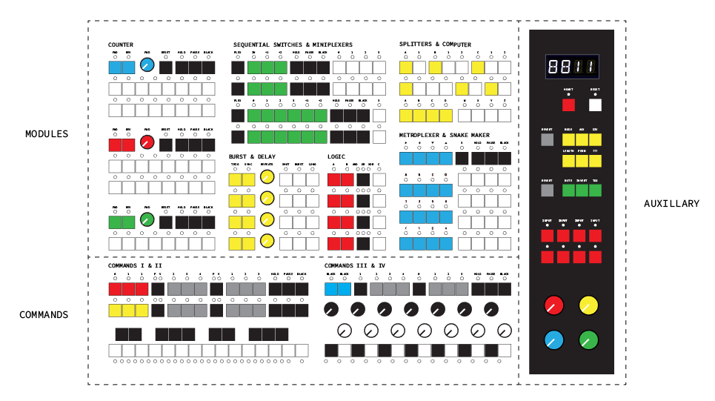

Layout and functional zones of Destiny Clock

**Button-based Node Patching**

**Automatic OR gate on Inputs**

Each input supports up to 16 connections from outputs. An automatic OR gate on every input is used to normalize the incoming signals.

**Holding vs Tapping a Button**

Tapping will show the current states of whatever button has been pressed. For instance, tapping the MUTE button will show every node that’s been muted. Tapping again will return to Patch/Performance mode.

Holding MUTE will allow the user to continue to view LED output of modules and press buttons with the functionality of mute. This is useful for observing the direct effects of making a change.

**Undo Last Patch**

More often than not, making a patch will create unexpected results. Sometimes these results aren’t what you want. For this reason, UNDO can help out. Pressing UNDO will delete your last patch (and reset both modules?).

Holding UNDO and then pressing RESET will delete all patch cables and reset all modules to their initialization states.

**Modules**

**Inputs**

The colored keys of the modules represent their inputs. Most black keys also behave as inputs. function as inputs.

**Outputs**

All white keys on Destiny Clock

**Reset**

The counter modules anter modules act as the primary signal generators. They will generate an output at a rate determined by the posi

**Hold/Pause/Clear**

These activate before an input signal.

**Pause**

The counter modules anter modules act as the primary signal generators. They will generate an output at a rate determined by the position of the potentio

**Clear**

The counter modules anter modules act as the primary signal generators. They will generate an output at a rate determined by the position of the potentio

**Signal Types**

**Node**

Nodes refer to both inputs and outputs.

**Patched**

If a connection has been made to an input or an output than it is considered to be PATCHED. Some nodes behave differently depending on their current PATCHED state.

**Trigger Signals**

A trigger is the act of a signal going from LOW to HIGH. Some inputs expect to receive a trigger in order to activate their function. Modules that need signal in order to “step” through their processes will usually require TRIGs. These signals are referred to throughout this manual as L>H for the moment that the signal changes its state.

**Gate Signals**

A gate signal is similar in that the signal goes from LOW to HIGH, but with the addition that the duration of the HIGH state also affects the behavior of the receiving module. The performance on a logic function will be dependent on how long each signal will be active.

**Isn’t a GATE also a TRIG?**

Yes. Modules that use TRIGs to operate will always behave indifferently to the duration of the signal. All that matters is the initial change from LOW to HIGH.

**Module Outputs**

The counter m

**Auxiliary Keys**

**System Display**

The System Display is a 4-digit alphanumeric screen located near the top right of Destiny Clock. It will display helpful information when selecting modes, configuring modules, setting controllers, and much more.

**Heartbeat**

Heartbeat receives a signal that will act as a global synchronization tempo for all modules. This means that if you change a parameter on a module that has been set to follow the heartbeat or patch one of its inputs/outputs then this change will only take effect at the next Heartbeat signal. Each module is set by default to follow the Heartbeat, but can be set to ignore it using a module’s submenus via the AUX shift key.

**Master Sync / Rest**

The counter modules anter modules act as the primary signal generators. They will generate an output at a rate determined by the position of the potentio

**Module Option Keys - Yellow**

The counter modules anter modules act as the primary signal generators. They will generate an output at a rate determined by the position of the potentio

**Node Modifier Keys - Green**

The counter modules anter modules act as the primary signal generators. They will generate an output at a rate determined by the position of the potentio

**Bank Keys - Red**

The counter modules anter modules act as the primary signal generators. They will generate an output at a rate determi

**Performance Mode**

*Alphanumeric Display*

The counter modules anter m

**COMMAND KEYS**

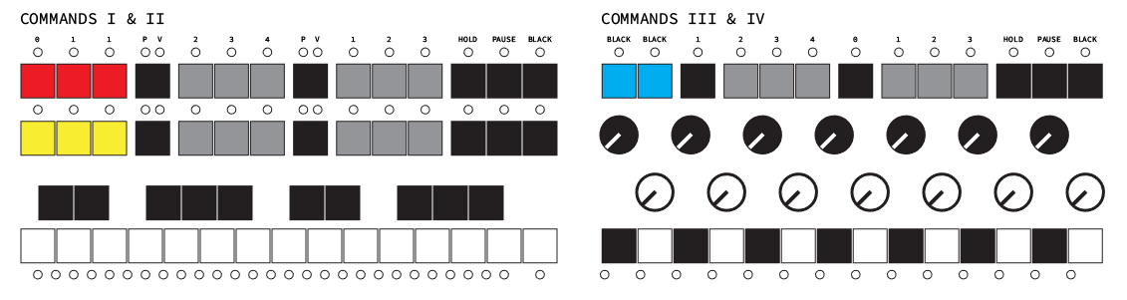

Layout and functional zones of Destiny Clock

*Alphanumeric Display*

The counter modules anter modules act as the primary signal generators. They will generate an output at a rate determined by the position of the potentio

**MODULES**

**Counter**

The Counter modules act as the primary signal generators for Destiny Clock. In order for other modules to operate, they will receive signals from the Counter modules, or receive them from another module that is receiving them from the Counter. The Counters have a collection of built in patterns that will generate signals on its outputs. These sequences can be stepped through automatically at a frequency determined by its RATE controller or at a rate determined by PATCHING its FWD or REV inputs.

**Inputs and Controls**

**INC**

INC is an input that upon receiving a TRIG signal will increment by one step of the sequence. When in performance mode, tapping the button will increment the sequence by one step. The effect will be displayed once the next TRIG signal is received on either INC or DEC.

**DEC**

DEC is an input that upon receiving a TRIG signal will decrement by one step of the sequence. When in performance mode, tapping the button will decrement the sequence by one step. The effect will be displayed once the next TRIG signal is received on either INC or DEC.

**INC and DEC in PERFORMANCE MODE**

While in PERFORMANCE MODE, pressing either button will increment or decrement the current step of a sequence. This is helpful when offsetting the rhythmic sequence of the module or attempting to manually synchronize it with another.

**RATE when INC and DEC are UNPATCHED**

RATE determines the frequency at which the sequence will be stepped through. Turning the dial clockwise will increase the frequency. Turning the dial entirely counter-clockwise will stop the sequence from advancing.

**RATE when INC or DEC is PATCHED**

If either INC or DEC is PATCHED then RATE will no longer function to control frequency and the sequence will only advance when either input receives a TRIG signal. RATE now controls the duration that output signals will be HIGH when in the LENGTH Mode.

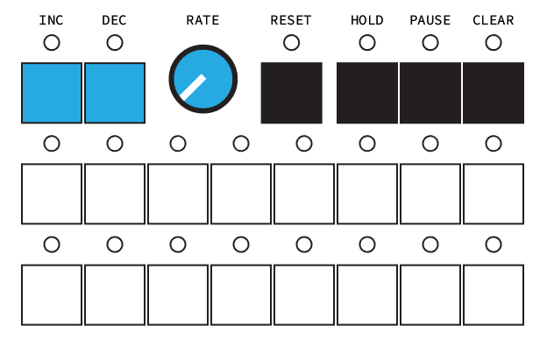

Layout and functional zones of Destiny Clock

**Pattern Selection**

**Changing Patterns**

There are a total of 16 patterns available to choose from. They are accessed by pressing the MODE button, which replaces the current outputs LED indication of the Counter module with its mode selection information. The pattern is selected by first choosing a type of sequence (the left four buttons) and then a subtype (the four buttons on the right). Pressing the MODE button again will return to

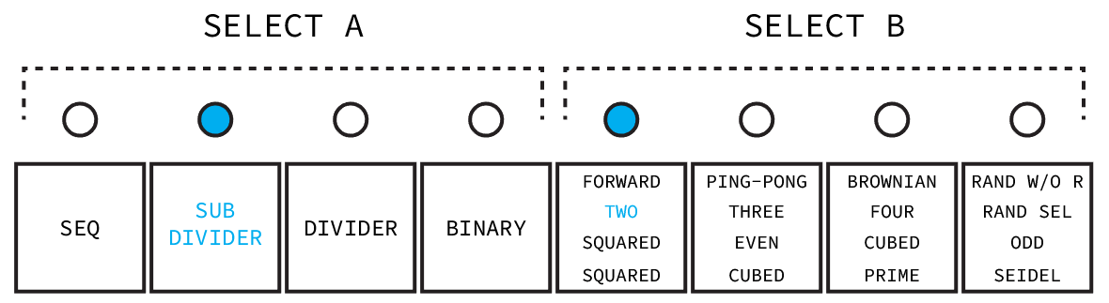

The LEDs indicate that the Subdivier Two pattern has been selected.

**8 and 16 Step Sequences**

All patterns can operate as either sequences of 8 or 16 steps. This is achieved by selecting the same pattern for both top and bottom 8 step banks.

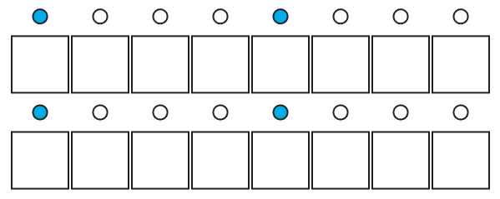

This indicates that the Sequencer Forward pattern has been selected for

both banks and that when the PATTERN key is released the sequence will

initialize on its first step and run for 16 steps before repeating.

**Pattern Selection and Initialization**

Selecting any pattern for either bank, even if it is the currently selected pattern, will initialize the sequence to its first step. Selecting a matching pattern in order to use 16 steps will reset both banks so that they may act as one.

**Patterns**

**1 : Sequencers**

These patterns only have one step activated at a time. The inputs and outputs determine which step is currently activated. The thicker horizontal black line indicates the point at which the sequence starts to repeat itself.

A : Forward

Whenever INC receives a TRIG or the frequency set on the RATE control is HIGH, the sequence will advance one step.

B : Ping-Pong

This is a similar concept to the Forward pattern except that when the end of the sequence is reached, instead of returning to the first step, the direction of the sequence changes. In this mode, the DEC input reverse the direction of the sequence, rather than step backwards, when it receives a HIGH signal.

C : Brownian

Otherwise known as the “drunk walk” function, when one of inputs receives a HIGH signal, the Brownian pattern will make a 50/50 decision on whether to ignore it or not. The effect is a staggered and much less predictable version of the Forward pattern.

D : Random without Replacement

This sequence will play all of its 8 steps in a random order without repeating any step. Once every step of the sequence has been played, a new random sequence will be generated. Permutations do not affect this pattern.

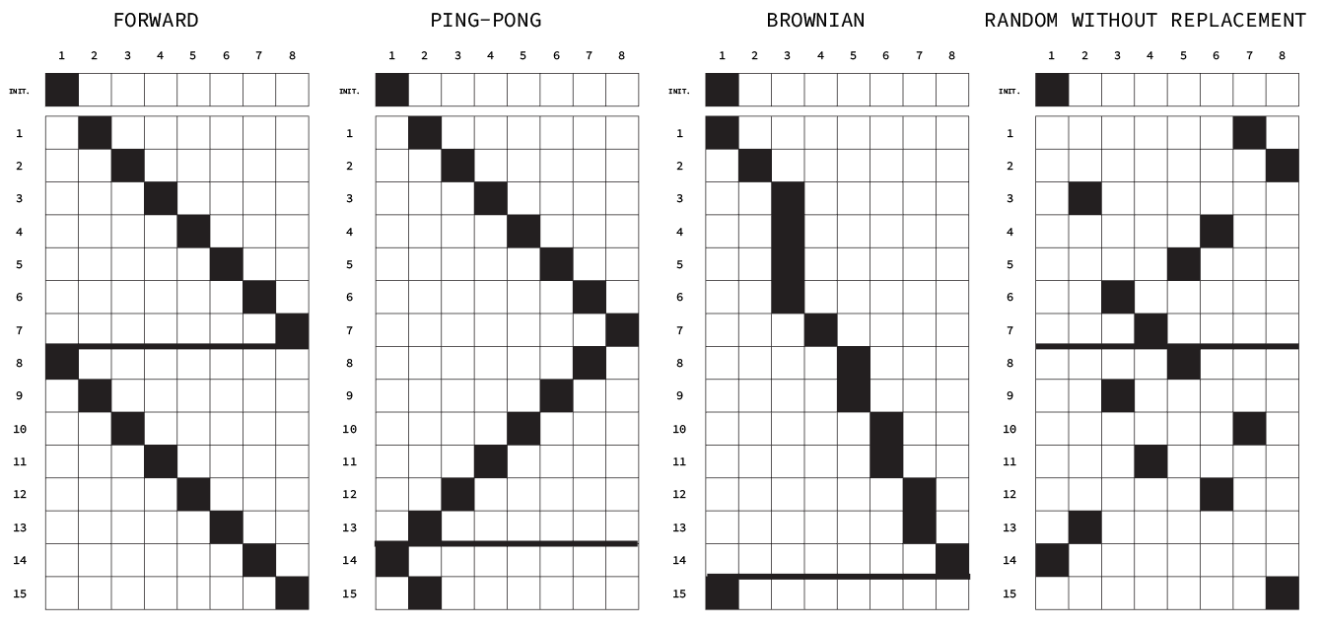

The first 16 outputs of the Sequencer patterns where

only the INC or RATE input is used.

**2 : Subdividers**

The idea behind the subdivider is to expand upon the possible outputs of the Sequencer options. Patterns are composed of several miniature sequencers. The first one, upon completing and resetting its own pattern, drives the next sequence in line and so on until there are no more steps. These patterns are excellent sources for composing rhythmic arrangements.

A : Two

Composed of 4 sets of 2 step long sequences.

B : Three

Composed of 3 sets of 3 step long sequences with the last pattern missing a step. That step is still considered functionally, but is inaccessible for use.

C : Four

Composed of 2 sets of 4 step long sequences.

D : Random Scaled

Each output will randomly generate a HIGH output signal based on the probability of its channel. The function of the DEC input changes as well. When activated it will invert the probability of a signal being generated. The first step for example would have a 90% chance of activating instead of a 10% chance as if it had been driven by a signal received by the INC input.

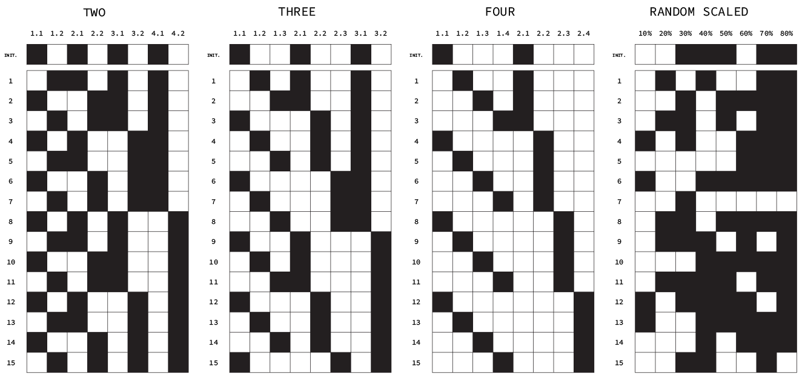

The first 16 outputs of the Subdivider patterns where

only the INC or RATE input is used.

**3 : Dividers**

Dividers break up an incoming signal into subharmonics. If the incoming signal goes from LOW to HIGH or from HIGH to LOW an internal counter is advanced by 1. If the counter is divisible by one of the output channels dividers then it will toggle its current state. Normally, these modules would start at zero, but for the purposes of musicality, they start at 2. Another difference is that the sequence advances on the rising edge rather than the falling edge of an input signal.

A : Squared

This pattern uses increasing powers of 2 to divide the input frequency. The effect is that each step is half the rate of the one that precedes it with the first step being half the rate of the input.

B : Cubed

Because Cubed uses an odd number, it will generate an output signal from its first step sometimes on the falling edge of an input signal. The divisors used here are intended for the purposes of a compound time musical output.

C : Even

The outputs utilize the first 8 even whole numbers to act as divisors. Similar to how Squared operates, but with a more looser harmonic relationship between outputs.

D : Odd

The outputs utilize the first 8 odd whole numbers starting at 3 to act as divisors. Like in Cubed, these outputs will often toggle their states on the falling edge of the input signal.

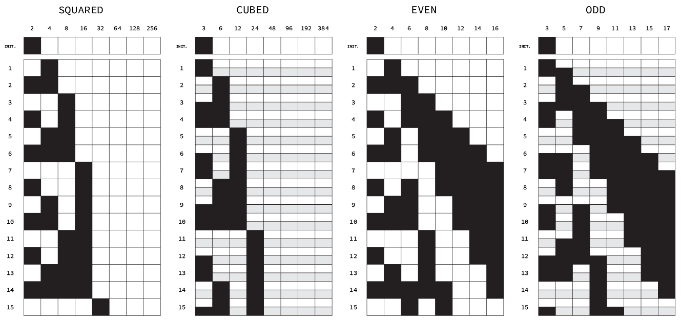

The first 16 outputs of the Divider patterns where

only the INC or RATE input is used.

**4 : Binaries**

The Binaries are the strangest patterns available. They operate by incrementing a number by one, applying a mathematical function to that number, translating the result into binary, and then using the states (1 or 0) of each digit of the binary number (in reverse order) to act as the output signal. These sequences could continue forever, but for simplicity they all start at 1 and reset after 256 steps.

A : Squared

The number is multiplied by itself. The second digit (remember that the order of digits has been reversed for the sake of musical readability) is ignored, because it is always 1.

B : Cubed

The number is multiplied by itself two times.

C : Prime

This sequence uses the first 256 prime numbers starting at 2. The first digit is ignored, because it is always 1.

D : Seidel

This is a pattern, I know literally nothing about except that it generates an interesting pattern. For anyone interested, you can find out more about it [here](http://mathworld.wolfram.com/Seidel-Entringer-ArnoldTriangle.html).

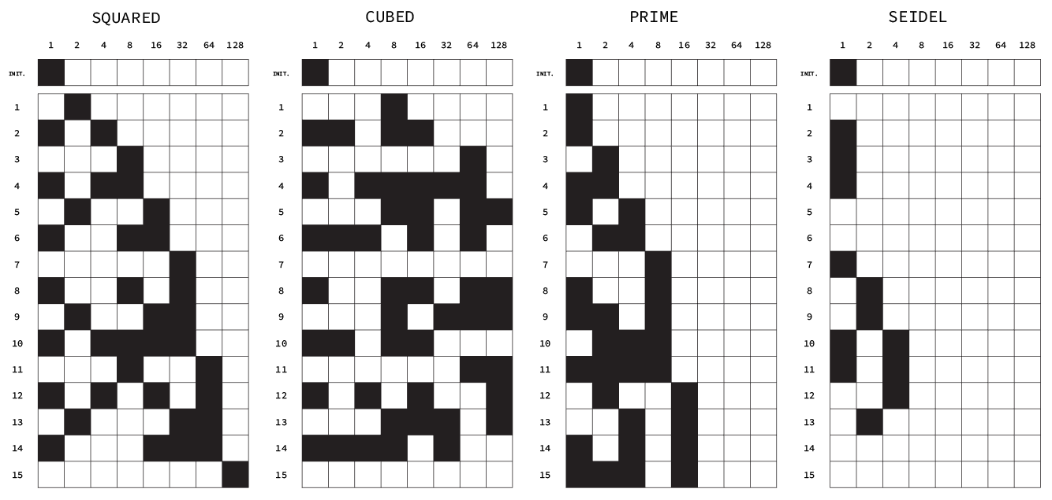

The first 16 outputs of the Binary patterns where

only the INC or RATE input is used.

**Permutations**

Pressing the PERM key will replace the outputs LED indication with the permutation selection. Pick one of the 8 keys to scramble the sequence. The permutations perform similarly to an arpeggiator function depending on how you’ve assigned the outputs. Currently, permutations only work for 8 step sequences. 16 step sequences will play the first bank’s permutation and then steps 9-16 using the same permutation map..

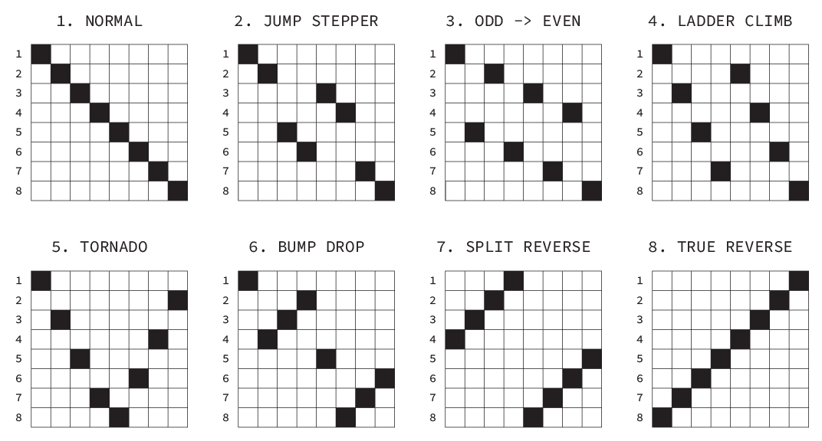

These diagrams represent the permutations options available.

**Output Effects**

Tapping the AUX modifier key will replace the LED output display with an effect selection display. Press any of the 5 buttons to apply an effect to the output. The default effect is Normal.

Different effects can be applied to each 8 step bank. If INC and DEC are unpatched, the RATE will control both the internal frequency and the length effect, with the internal frequency taking priority for displaying information on the alphanumeric display.

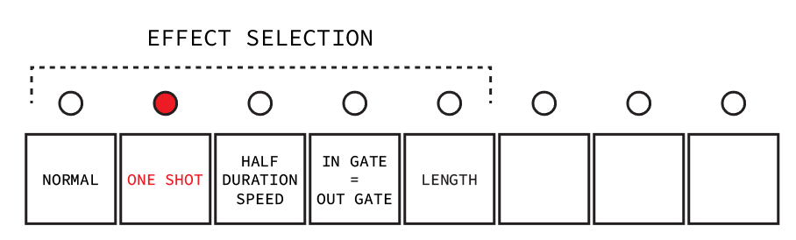

These diagrams represent the permutations options available.

**Normal**

Normal mode plays the steps in sequential order from 1-8 or 1-16.

**One Shot**

Effect isn’t observable with Sequence patterns.

The One Shot effect converts outputs that last longer than a single step to the duration of the step that they were activated on. Outputs that last only a single step (like all of those of the Sequencer patterns) will not be effected by One Shot.

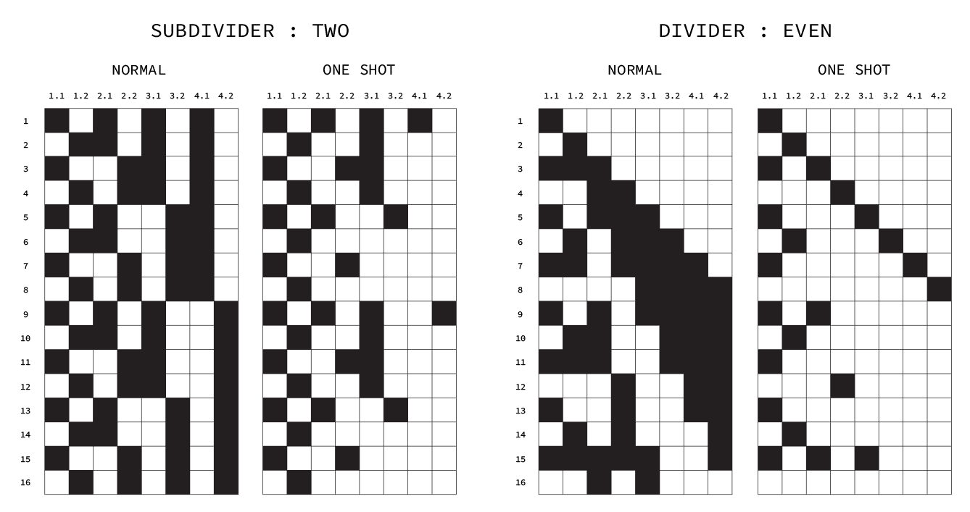

These diagrams represent the permutations options available.

**Half Duration/Speed**

Different behavior when INC or DEC is PATCHED

When using an internal frequency that’s been set by the RATE knob, Half Duration will make every output last half as long as it normally would without altering the speed at which outputs occur. If this effect is applied to when INC or DEC has been PATCHED then the effect will not only halve the duration but also the speed. This is due to it being impossible to know when the next TRIG from the incoming signal to INC or DEC will be. Whereas in the case of an internal frequency (which is steady and predictable), it can be determined when the next step will occur, so it can be determined how long the step should be without affecting the overall frequency.

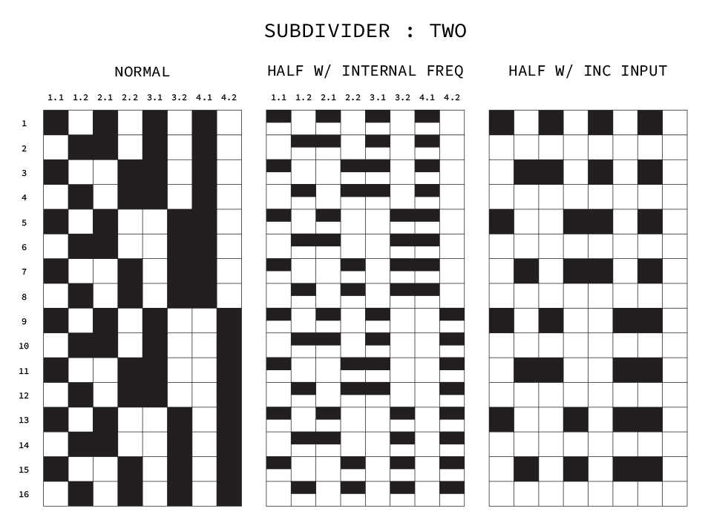

These diagrams represent the permutations options available.

**In Gate = Out Gate**

Only works when INC is PATCHED

This effect will make it such that whenever the signal on INC or DEC is HIGH the output signal from whatever channel is currently active, will also be HIGH. If the effect is set and there is no signal PATCHED to INC, then it can be manually activated by pressing INC or DEC

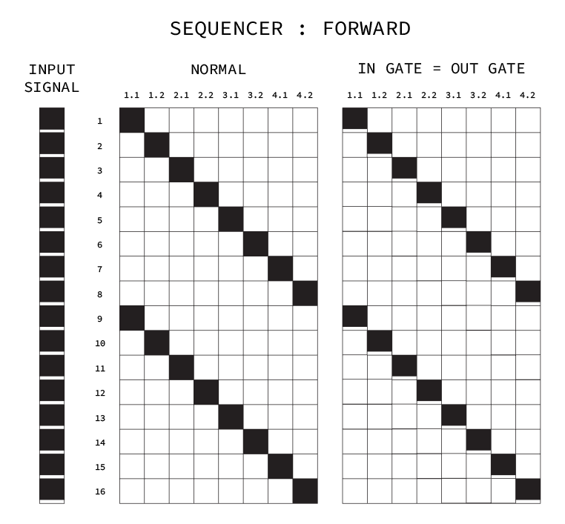

These diagrams represent the permutations options available.

**Length**

Only works when INC or DEC is PATCHED

If INC of DEC is patched, the RATE knob will no longer control an internal frequency for driving the pattern. It now controls the duration of outputs when the Length output effect is selected. The duration of steps in milliseconds can be seen on the alphanumeric display.

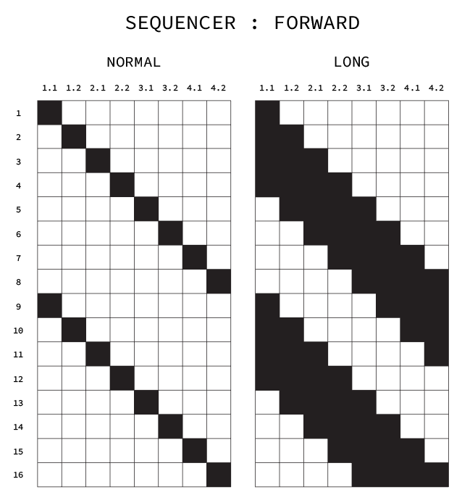

These diagrams represent the permutations options available.

**Aux Controls**

Tapping the AUX modifier key will also bring up options for configuring the way the module updates changes to its performance and how it receives and releases incoming signals while Hold, Pause, or Clear are active.

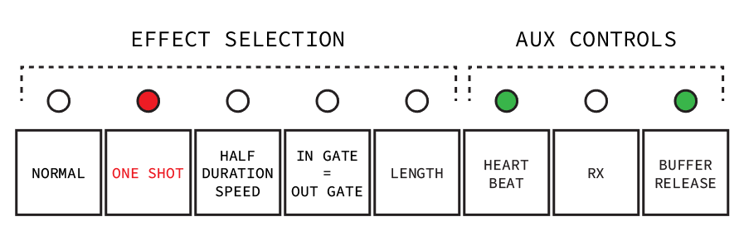

These diagrams represent the permutations options available.

**Heartbeat**

Default : Not activated

Activating heartbeat means that any changes made to the module (such as patching its outputs to other modules inputs or changing any of its AUX or MODE controls) will sync with the master Heartbeat of the system rather than activating on the next TRIG signal received by either the internal frequency generated by the RATE controller or the INC or DEC inputs.

**Hold/Pause/Clear Sequence Updating (RX)**

Default : Not activated

Sequence updating allows for incoming TRIGS to update the sequence even while Hold/Pause/Clear is active.

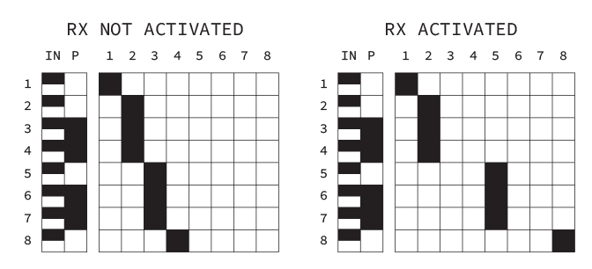

Where P is Pause and a Sequencer Forward pattern is used.

**Hold/Pause/Clear Buffer Release**

Default : Not activated

Buffer release allows for the sequence to me updated the moment Hold/Pause/Clear is released rather than with the next TRIG signal on INC or DEC.

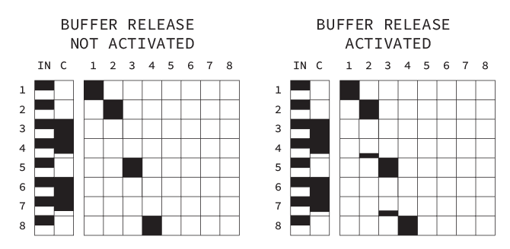

Where C is Clear and a Sequencer Forward pattern is used.

**Multiplexer & Sequential Switch**

These four modules are used to route incoming signals to different outputs.

**Routing 1 Input Signal to 1 of 4 Outputs**

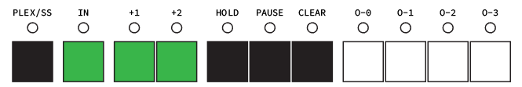

Layout and functional zones of Destiny Clock

**Plex / SS**

All modules default to Multiplexer mode and this is indicated by an unilluminated LED. Pressing this button will toggle between Multiplexer and Sequential Switch modes. When Sequential Switch mode is active, the LED will be illuminated.

**IN**

This input receives the signal to be routed to 1 of 4 outputs. This input is considered ALWAYS ON unless PATCHED.

**O-0, O-1, O-2, and O-3**

These outputs will receive the routed input based on the states of selection inputs (if in Multiplexer mode) or the current step (if in Sequential Switch mode).

**+1 and +2 in Multiplexer Mode**

+1 and +2 act as the two-bit selection switch that determines which output the IN signal will be routed to.

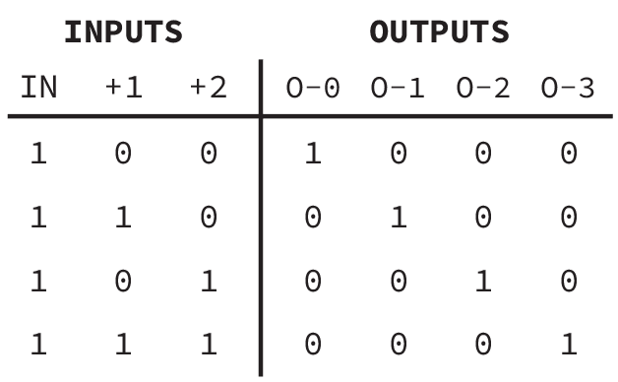

This diagram represents all possible routing combinations of

the selection switch and assumes the IN signal is always HIGH.

**+1 and +2 in Sequential Switch Mode**

While in PERFORMANCE MODE, pressing either button will increment or decrement the current step of a sequence. This is helpful when offsetting the rhythmic sequence of the module or attempting to manually synchronize it with another.

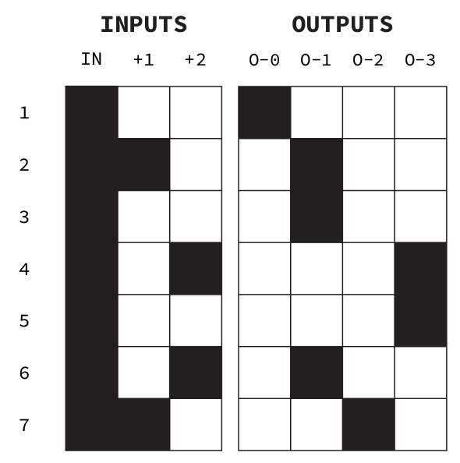

Layout and functional zones of Destiny Clock

**Routing 1 of 4 Input Signals to 1 Output**

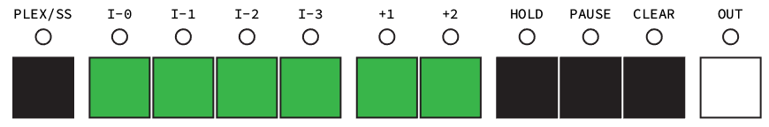

Layout and functional zones of Destiny Clock

**I-0, I-1, I-2, and I-3**

These inputs receive the signals to be routed to output. I-0 is ALWAYS ON unless any of the inputs are PATCHED.

**OUT**

This output will receive one of the routed input signals based on the states of selection inputs (if in Multiplexer mode) or the current step (if in Sequential Switch mode).

**+1 and +2 in Multiplexer Mode**

+1 and +2 act as the two-bit selection switch that determines which of the inputs will be routed to OUT. The diagram below is color coded to help visualize which signal is being routed.

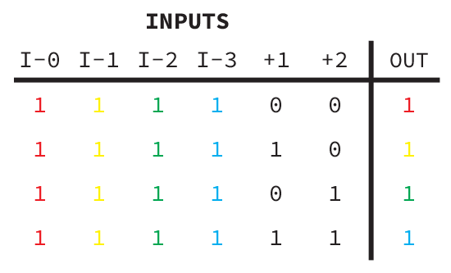

This diagram represents all possible routing combinations of

the selection switch and assumes the IN signals are always HIGH.

**+1 and +2 in Sequential Switch Mode**

While in PERFORMANCE MODE, pressing either button will increment or decrement the current step of a sequence. This is helpful when offsetting the rhythmic sequence of the module or attempting to manually synchronize it with another.

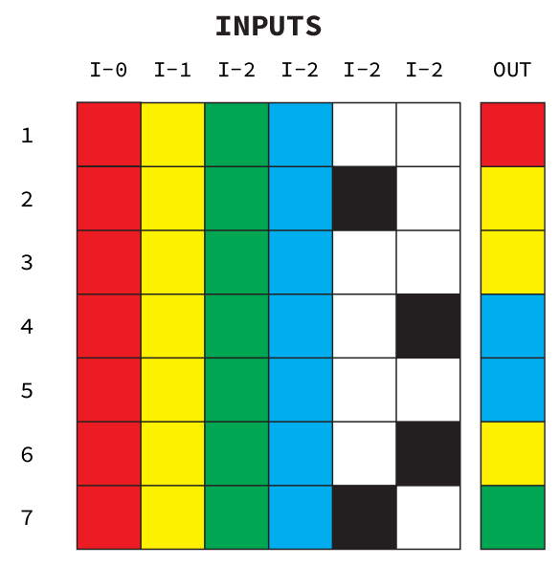

Layout and functional zones of Destiny Clock

**Permutations**

The outputs and inputs on both 1 to 4 and 4 to 1 modules can have a permutation applied to it. Pressing the PERM key will shift the module into a selection mode. Pressing 1 of its output or input keys will apply the effect.

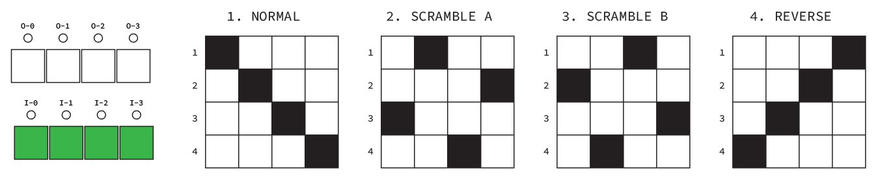

These diagrams represent the permutations options available.

**Input and Output Effects**

Tapping the AUX modifier key will replace the LED output display with an effect selection display. Press any of the 3(4) buttons to apply an effect to the input or output depending on the router type. The default effect is Normal.

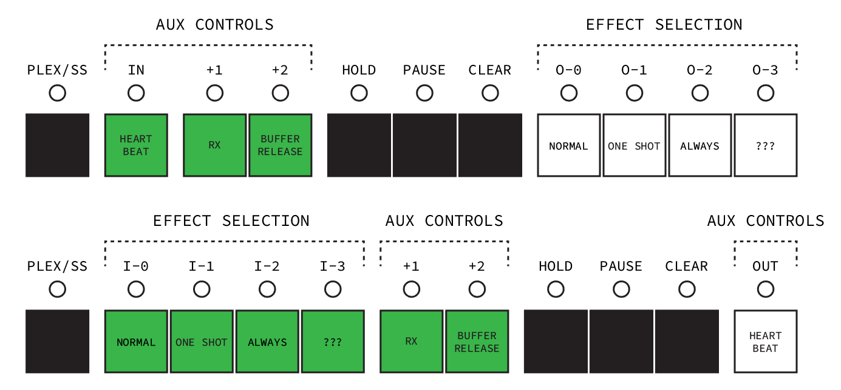

These diagrams represent the permutations options available.

**Normal**

Only one gate signal is allowed to pass through for every change of the selection bits. The duration of the gate signal is not considered.

**One Shot**

Only one gate signal is allowed to pass through for every change of the selection bits. The duration of the gate signal is not considered.

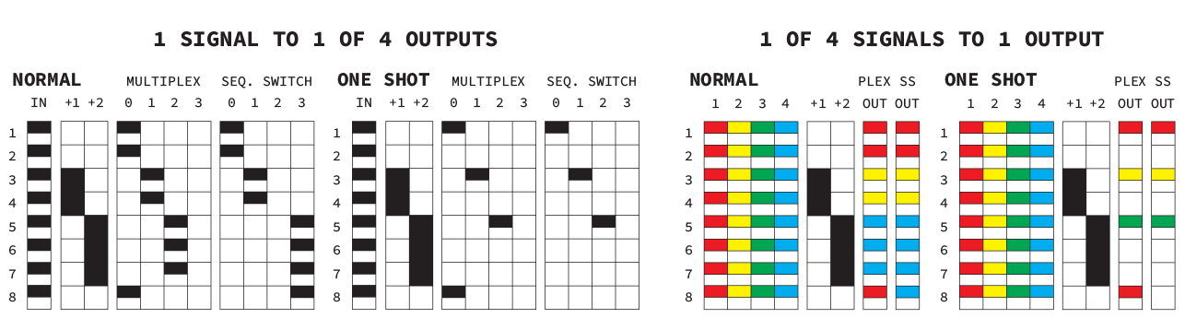

These diagrams represent the permutations options available.

**Always On**

Always on will make it so all signals received on the signal inputs are ignored and considered always HIGH. In the case of the 4 to 1 router, the first signal is HIGH while all others are low. This behavior is default if the signal inputs are left unpatched. This option is available to the user who wishes to override any patches that have been made.

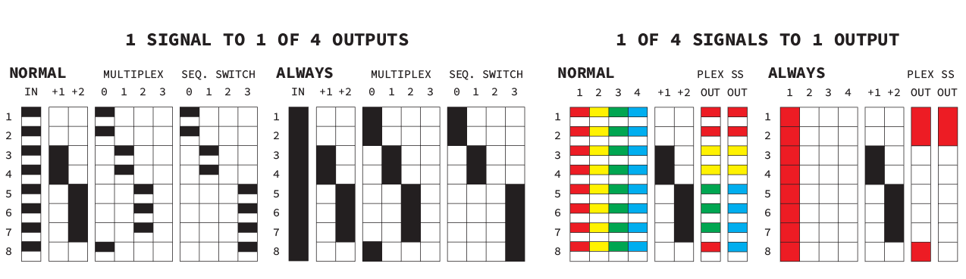

These diagrams represent the permutations options available.

**?????**

There’s room for one more effect slot, but I can’t think of any more.

**Aux Controls**

Tapping the AUX modifier key will also bring up options for configuring the way the module updates changes to its performance and how it receives and releases incoming signals while Hold, Pause, or Clear are active.

**Heartbeat**

Default : Not activated

Activating heartbeat means that any changes made to the module (such as patching its outputs to other modules inputs or changing any of its AUX or MODE controls) will sync with the master Heartbeat of the system rather than with the next with the next IN, +1, or +2 signal.

**Hold/Pause/Clear Sequence Updating (RX)**

Default : Not activated

Sequence updating allows for incoming TRIGS to update the sequence even while Hold/Pause/Clear is active.

**Hold/Pause/Clear Buffer Release**

Default : Activated

Buffer release allows for the sequence to me updated the moment Hold/Pause/Clear is released rather than with the next with the next IN, +1, or +2 signal.

**Burst & Delay (& Metropolis Sequencer)**

Burst & Delay allow for time manipulation and repetition of incoming signals. The Metropolis mode arranges the channels of burst into a sequencer.

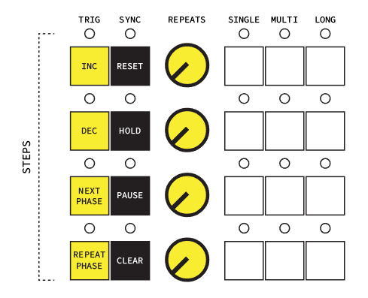

Burst & Delays layout and controls. ‘STEP’ and the labels on the buttons represent

additional controls for Metropolis mode.

**Burst Mode**

The Burst function allows for an L-H signal received by the TRIG input to release the next X number of GATE signals from the SYNC input where X is a number set by the REPEATS controller. Once X number of outputs have occurred no more will be allowed until another L-H signal is received on the TRIG input. TRIG is activated before the number of REPEATS has finished, then the REPEATS counter will reinitialize.

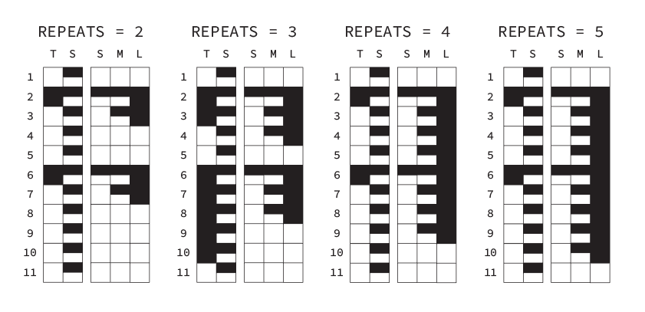

Output patterns based on the same input signals with different REPEATS.

**TRIG**

Receives the signal that allows for a chain of repeated signals to be generated.

**SYNC**

The signal received by sync will set the rate and duration of the output signals on S, M, and L.

**REPEATS**

Sets the number of repeats between 1-16.

**S (Single or One-Shot)**

Outputs one signal equal to the duration of the SYNC input signal per TRIG activation.

**M (Multi or Medium)**

Outputs signals equal to the duration of the SYNC input signal for each REPEAT of the chain.

**L (Long)**

Outputs one signal equal to the duration of the SYNC input signals for each REPEAT of the chain. L’s output will become inactive when the next SYNC signal that is not part of a chain of repeats is received.

**Delay Mode**

Delay receives and incoming signal on TRIG and outputs it after an interval of time (i.e. a delay) based on the setting of the REPEATS controller if SYNC is unpatched.

If SYNC is patched then an average time between L>H input signals will be used to compute an average time to serve as the delay length. This time then be altered by setting the REPEATS knob anywhere between 1/64 and 2.

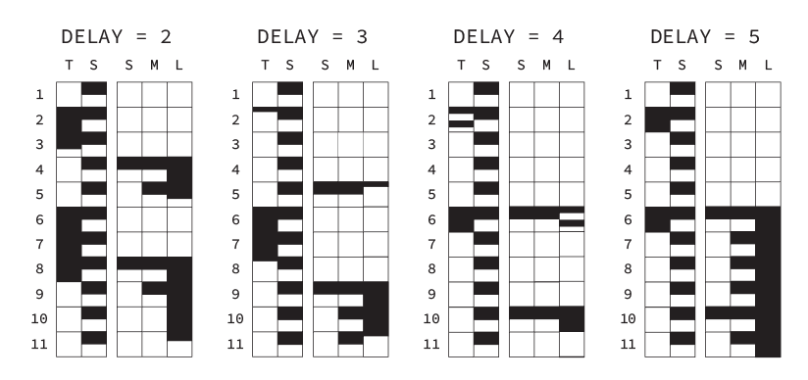

Output patterns based on the same inputs with different DELAY settings.

**Metropolis Mode**

Metropolis acts a bit like a 2D sequencer where each step can contain several steps (or sub-steps) within it. The number of sub-steps in each step is set by that steps REPEAT knob. So, if a channel has been set to 3 steps, those steps’ outputs will be activated by each L>H signal received by INC. After all sub-steps have been completed, the next step’s sub-steps will be stepped through with each INC input. Take note that the duration of the outputs is the same as the duration of the signal on INC.

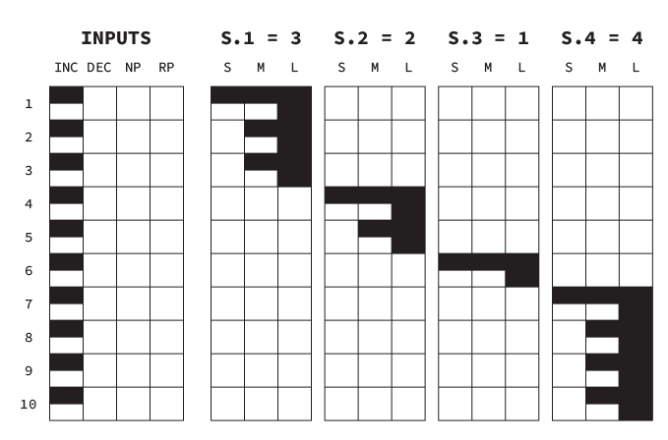

Output patterns based on a steady INC input signal.

**Mode Selection**

Holding or tapping the MODE button on the control panel and then pressing one of the top three white buttons on Burst & Delay will allow for the mode to be changed.

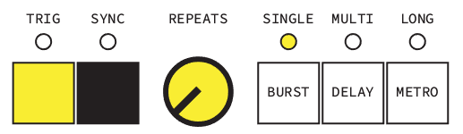

Selecting modes for Burst & Delay. The current mode is indicated by and LED

as well as the system display.

**Logic**

The Logic module applies a logic gate (AND, OR, XOR, NAND, NOR, XNOR) to a pair of input signals and outputs the results. There are four channels available.

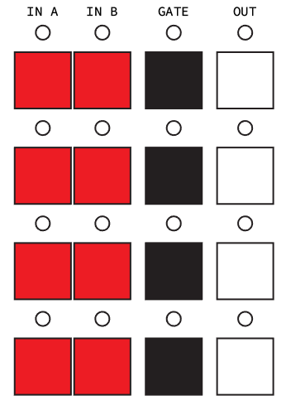

Layout and functional zones of Destiny Clock

**IN A and IN B**

These inputs accept signals to be compared by the logic gate.

**GATE**

Pressing and holding (tapping?) the GATE button will change the alphanumeric display to the currently selected gate. Continuing to hold GATE and pressing either IN A or IN B will cycle through logic functions. The current logic function will be displayed on the system display The default gates for each channel from top to bottom are AND, OR, XOR, and XNOR.

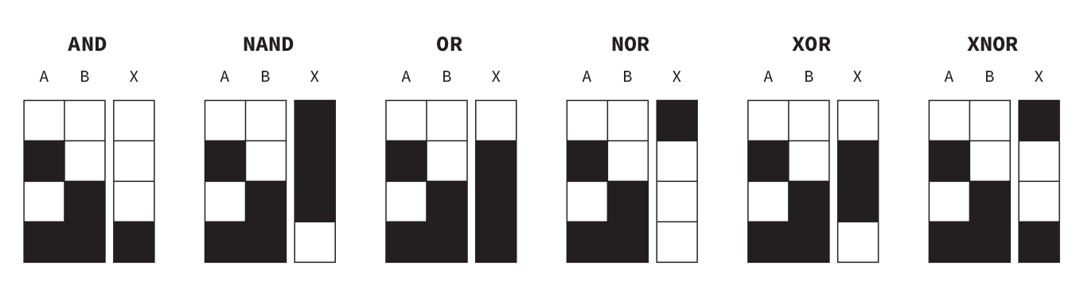

Layout and functional zones of Destiny Clock

**OUT**

OUT is the result of the logic function applied to the two inputs. Consider that some logic functions will output HIGH even with no inputs.

**Splitters & Computer**

This section is composed of two modules that act as supports for the other modules. There’s nothing particularly complicated about them, but they may come in handy.

**Splitters**

The top module is broken out into 5 interdependent parts. Each accepts an input and then duplicates that input’s signal across its 1-3 outputs. These outputs can have NODE EFFECTS applied to them like mute, invert, and toggle without affecting the original input signal.

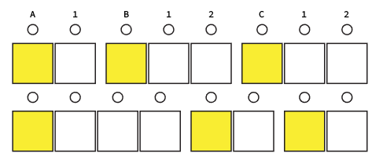

Layout and functional zones of Destiny Clock

**Button**

A, B, C, X, Y, and Z default as button toggle outputs. This means that their outputs are generated entirely manually. This is used for controlling the signal flow between modules. Button presses can only be activated in performance mode and are be default synced to the Heartbeat. This can be changed by pressing the HEART button.

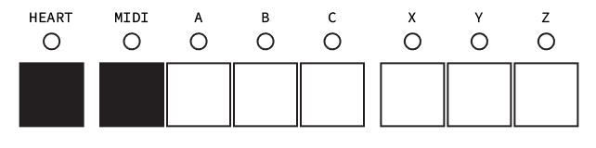

Layout and functional zones of Destiny Clock

**MIDI IN**

The MIDI button allows for A, B, and C to change from button outputs to MIDI IN channels. When activated these outputs will receive MIDI information from Channel 5 on notes 60, 61, and 62 respectively.

**Metroplexer & Snake Maker**

Metroplexer & Snake Maker is the most complex module of Destiny Clock. It has several modes and generates outputs based on a 4x4 grid rather than a linear arrangement.

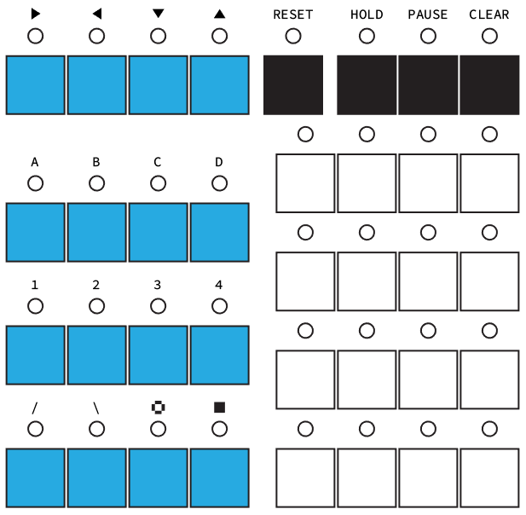

Layout and functional zones of Destiny Clock

**Lights Out - PLUS**

Similar to the game “Lights Out” by Tiger Electronics, this mode takes an input and then toggles its analogous output along with the 4 adjacent outputs located next to it. The default mode is to have outputs toggle on/off with each TRIG input.

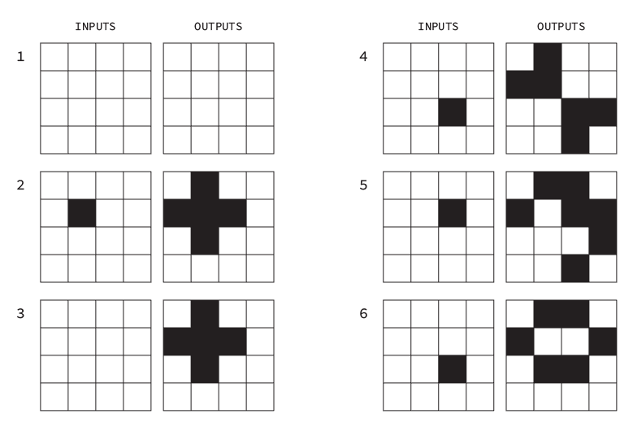

Layout and functional zones of Destiny Clock

**Big Lights Out - BLUS**

Same idea as Lights Out mode except now inputs trigger 12 adjacent outputs rather than 4.

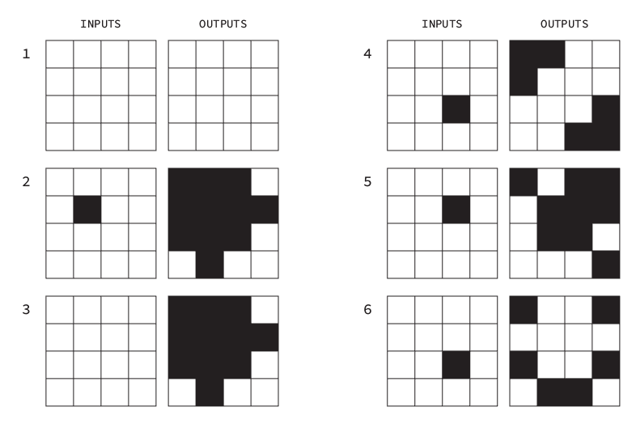

Layout and functional zones of Destiny Clock

**BLOK**

Slasher is the mode that the panel graphics refer to. There are 4 banks each with 4 controls that affect the outputs.

1 : → , ← , ↑ , ↓

The arrows refer to the direction that the current output grid can be offset by. Activating an arrow always shifts the grid by 1. If the shift forces some outputs to be pushed off the matrix, they wrap around to the other side.

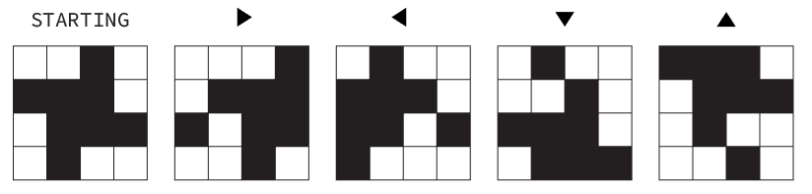

2 : A, B, C, D

These inputs will toggle all outputs in their respective columns. The examples below are the result of the inputs being activated on a blank matrix.

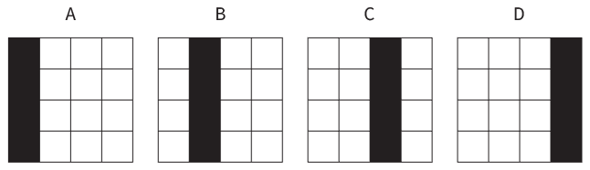

3 : 1, 2, 3, 4

When activated, these inputs will cause a row of outputs to invert their current states.

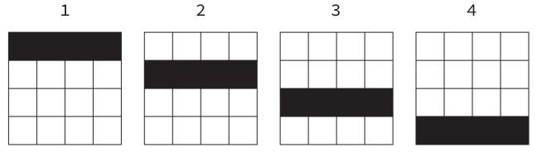

4 : / , \ , || , =

These inputs create the unique output patterns indicated by their symbols.

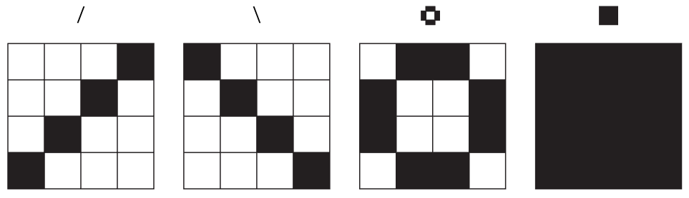

**Snake Maker - SNEK**

Snake Maker uses the 4 arrow inputs to move a single signal across the output matrix. If the signal is pushed off the edge of the matrix, it will automatically wrap around to the opposite side. Using this mode with HOLD activated will give the effect of a snake similar to the from the famous game by the same name.

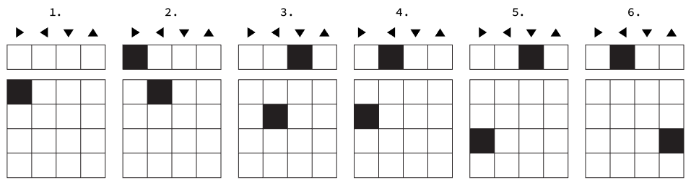

Layout and functional zones of Destiny Clock

**Output Effects**

Tapping the AUX modifier key will replace the LED output display with an effect selection display. Press any of the 4 (top) buttons to apply an effect to the outputs.

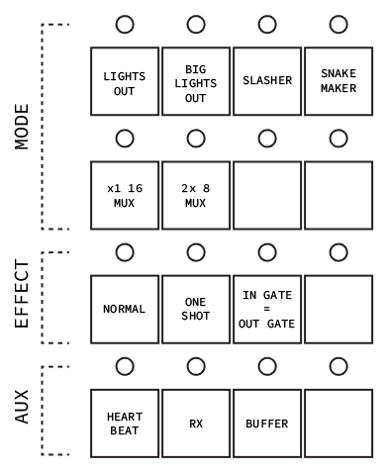

Layout and functional zones of Destiny Clock

**Aux Controls**

Tapping the AUX modifier key will also bring up options for configuring the way the module updates changes to its performance and how it receives and releases incoming signals while Hold, Pause, or Clear are active.

**Heartbeat**

Default : Not Activated

Activating heartbeat means that any changes made to the module (such as patching its outputs to other modules inputs or changing any of its AUX or MODE controls) will sync with the master Heartbeat of the system rather than with the next TRIG from any of the inputs.

**Hold/Pause/Clear Sequence Updating (RX)**

Default : Not Activated

Sequence updating allows for incoming TRIGS to update the sequence even while Hold/Pause/Clear is active.

**Hold/Pause/Clear Buffer Release**

Default : Not Activated

Buffer release allows for the sequence to be updated the moment Hold/Pause/Clear is released rather than with the next with the next TRIG signal on one of the inputs.